International Day Performances!
We want you to perform at International Day!
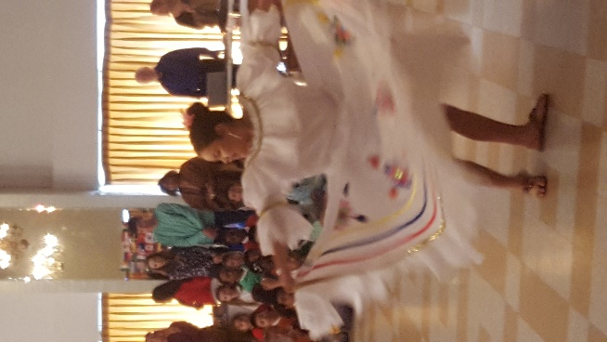
International Day is on: Friday, Feb. 4 (The last day of Catholic Schools Week) - and we want would love for you to share your cultural and artistic talents!
If you would like to perform a dance or song from your country- please do the following:
-Schedule with Mrs. Balog: Katharine.Balog@stjuderockville.org
-Send Mrs. Balog the music through a downloaded song. The music cannot exceed 2 minutes. We must keep performances under 2 minutes due to time constraints of the event.
-Send the following information to Mrs. Balog:
Family Name and Email:____________________________________________________________
My children are in the following grades:_______________________________________________
Country represented:_____________________________________________________________
Describe the performance your child will participate in:
_______________________________________________________________________________________________________________________________________________________________________________________________________________________________________________________________

