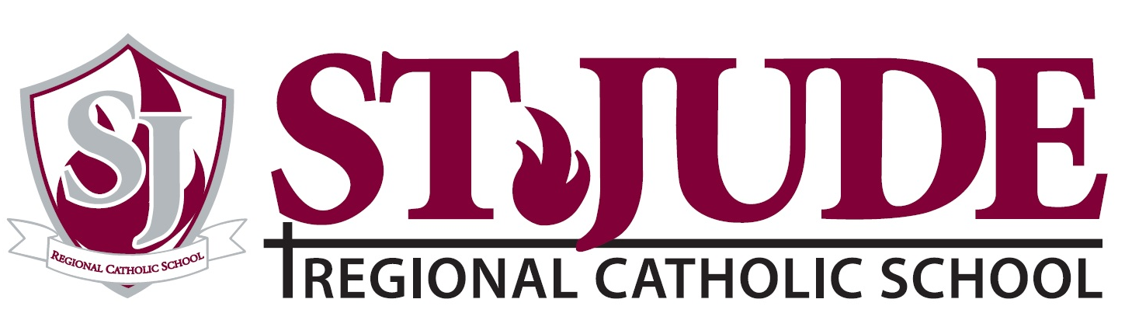

TUITION POLICY STATEMENT

Last Name:

Parents/Guardians:

Check one: Catholic Specify Parish:

Tuition rates for our students, including the Sibling Grant, ($500.00 per student) for the 2023-24 school year are as follows:

Number of Children | Tuition Rate
1 Child | $8,670.00
2 Children K-8th Grade | $16,840.00
3 Children K-8th Grade | $25,010.00
4 Children K-8th Grade | $33,180.00
Tuition rates for pre-school for 2023-24 school year are as follows:
 | Tuition Rate
Pre-K (3 & 4 year old) | $9,573.00

I. The cost to educate each child for the 2023-24 School Year will approximate $16,707.00. This cost, less the net tuition rate is funded by the Shrine of St. Jude Parish and the various fundraising efforts of the school parents.

II. Tuition policy: St. Jude Scholarship for Families in Need-must apply for ADW Financial aid to qualify.
To qualify for the Pastors Recommendation form, families must submit the signed form from their Pastors or leader of their church on or before August 30, 2023. Alumni grants will be awarded to Grandparents and parents of St. Jude Regional Catholic School.

III. Tuition payments: Tuition payments are required to be made through TADS and may be made quarterly, semi-annually, or over a 10, 11or 12-month period. These payments are made on the 5th, 10th, 15th 20th or 25th of the month. [PLEASE NOTE: If you withdraw your child from enrollment in the school for any reason, tuition is NOT REFUNDABLE.]

IV. Withdrawal from school: The school must be notified by March 30 if your child(ren) is not returning for the 2023-24 school year. If the school is not notified, the 1st quarter tuition for the 2023-24 school year will be billed and considered due.

V. Late payment policy: Students will not be permitted to return to school on the first day unless a tuition agreement has been set up with the TADS and payments are current. As a new quarter begins, students will not be permitted back to school if the tuition account is in arrears. This policy will be strictly enforced. St. Jude Regional Catholic School reserves the right to cancel the registration of any student(s) whose family fails to satisfactorily meet its tuition or fees obligation. Student report cards, results of standardized testing and/or transfer information will not be sent or completed until all accounts and fees are paid in full.

I HAVE READ AND UNDERSTAND THE ABOVE RATES AND ALL POLICIES. I AGREE TO MAKE PAYMENTS IN ACCORDANCE WITH THE ABOVE POLICIES.

I HAVE READ AND UNDERSTAND THE ATTACHED LETTER REGARDING THE POLICIES AND PROCEDURES SET FORTH BY THE ARCHDIOCESE OF WASHINGTON.

__________________________________________________________________________________________
Parent/Guardian (signature and date)

