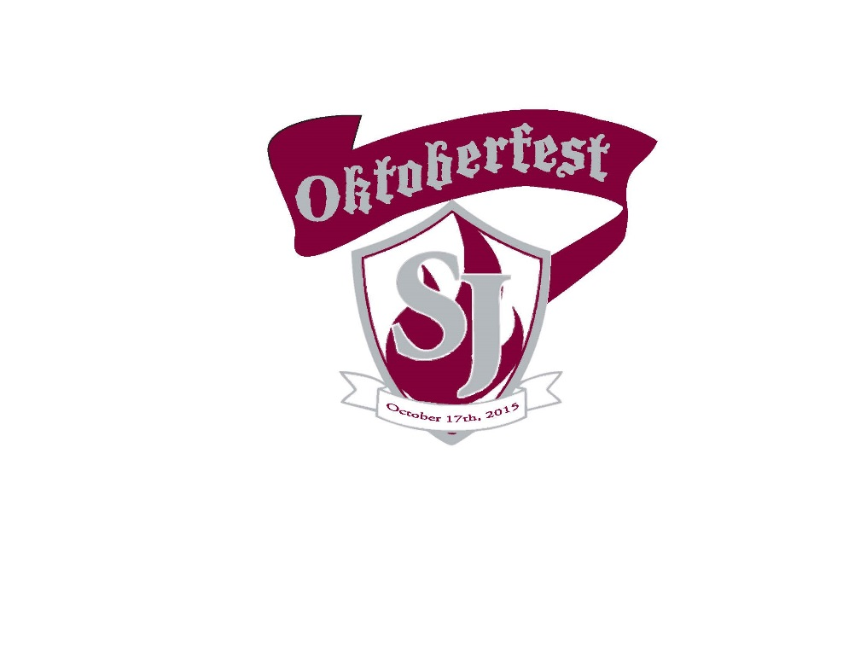
Join us for the 2019 St. Jude Oktoberfest

Wann? October 12, 2019, 6:30 – 10:30 PM
(rain or shine, indoor accommodations)

Wo? Im Biergarten (Thaddeus Room and Courtyard)

Wieviel? $25 per person until September 30
$30 per person after September 30
$35 per person at the door, includes food and drink

Was? Traditional German food, including, brats, potato salad, sauerkraut & German wein und bier!

College football will be broadcast on outdoor screens and cornhole will be the game of the day! There will also be music and a 50/50 cash raffle.

Get in the spirit and wear traditional German tracht (clothing) if you have it!
Oktoberfest is an adults-only event. Must be 21 with valid ID to enter.

Questions? Contact: Zendi Velasquez at zgvelasquez@gmail.com

RSVP & Payment requested by October 7, 2019.

You can also RSVP online by visiting www.stjuderockville.org & selecting the Oktoberfest link.
PAYMENTS: Checks (made payable to St. Jude Regional Catholic School), cash, or credit card payments will be accepted at the school office, in person Mon. – Fri. from 8 AM – 4 PM (credit cards by phone from 9 AM – 2 PM only)

----------------------------------------------------------------------------------------------

Name: __________________________________ St. Jude Graduate? (year or N/A): ________

Address: _____________________________________________________________________

E-mail: ___________________________________________Phone: _____________________
Registering multiple attendees? Please fill out their information below or an additional form.

Name: __________________________________ St. Jude Graduate? (year or N/A): ________

Name: __________________________________ St. Jude Graduate? (year or N/A): ________

Name: __________________________________ St. Jude Graduate? (year or N/A): ________

Name: __________________________________ St. Jude Graduate? (year or N/A): ________

